PACKING LIST
Photo | Item | Brand | Colour | Length  (cm) | Width  (cm) | Height  (cm) | Weight | Quantity per pallet | Nr. Of Pallets | Nr. Of Pieces per type in 40'' Container | Weight per pallet (KG) | Total Weight  (KG)
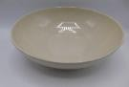 | Big Salad Bowl | Emile Henry | Cream | 25,50 | 25,50 | 8,50 | 1,14 | 270 | 5 | 1 350 | 308 | 1539
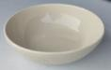 | Small Bowl | Emile Henry | Cream | 15,00 | 15,00 | 6,00 | 0,38 | 800 | 1 | 800 | 304 | 304
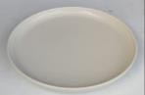 | Shallow Plate | Blomus | Cream | 27,00 | 27,00 | 3,00 | 0,87 | 450 | 1 | 450 | 390 | 390
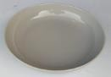 | Soup Plate | Blomus | Cream | 20,00 | 12,00 | 4,50 | 0,50 | 700 | 1 | 700 | 349 | 349
 | Desert plate | Blomus | Cream | 20,50 | 20,50 | 3,00 | 0,46 | 800 | 1 | 800 | 371 | 371
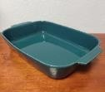 | Oven Dish | Medard de Noblat | Green | 36,00 | 24,00 | 7,00 | 1,93 | 200 | 2 | 400 | 386 | 772
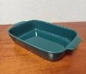 | Oven Dish | Medard de Noblat | Green | 24,00 | 15,50 | 5,50 | 1,60 | 420 | 1 | 420 | 672 | 672
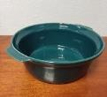 | Pot Handles | Medard de Noblat | Green | 24,00 | 260,00 | 10,00 | 1,56 | 260 | 1 | 260 | 407 | 407
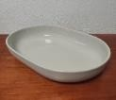 | Oven Dish | n/a | Cream | 34,00 | 23,00 | 7,00 | 1,90 | 220 | 0,5 | 110 | 418 | 209
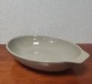 | Oven Dish | Staub | Grey | 33,00 | 23,00 | 7,00 | 1,80 | 220 | 2 | 440 | 396 | 792
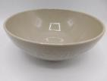 | Big Salad Bowl | Staub | Grey | 23,50 | 23,50 | 9,50 | 1,13 | 270 | 5 | 1 350 | 305 | 1526

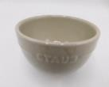 | Small Salad Bowl | Staub | Grey | 12,00 | 12,00 | 7,00 | 0,50 | 900 | 1 | 900 | 446 | 446
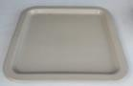 | Square Plate | Staub | Grey | 21,50 | 21,50 | 2,50 | 0,80 | 600 | 1 | 600 | 480 | 480
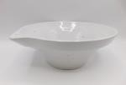 | Bowl | Potteryjo Stockholm | White | 25,00 | 13,00 | 12,00 | 1,71 | 460 | 0,5 | 230 | 785 | 392
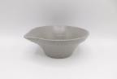 | Bowl | Potteryjo Stockholm | Grey | 19,00 | 10,00 | 9,00 | 0,78 | 700 | 1 | 700 | 546 | 546
TOTALS |  |  |  |  |  |  |  |  | 24 | 9 510 |  | 9 194
 |  |  |  |  |  |  |  |  | PALLETS | PIECES |  | NET WEIGHT

